DESIGN, DEVELOPMENT AND VALIDATION OF
SHOULDER-STRAP BASED POSTURE MONITORING SYSTEM

ABDUL NIZAM.K (21D202)
SAI SRI HARINE.C (21D241)
SARVESH RAJAVEL.R (21D245)
SYED ALTHAMISH UR RAHMAN (21D250)

Dissertation submitted in fulfilment of the requirements of the degree of 19D820 PROJECT WORK - II
BACHELOR OF ENGINEERING
Branch: BIOMEDICAL ENGINEERING
of Anna University


APRIL 2025
DEPARTMENT OF BIOMEDICAL ENGINEERING

PSG COLLEGE OF TECHNOLOGY
(Autonomous Institution)
COIMBATORE- 641 004
DESIGN, DEVELOPMENT AND VALIDATION OF SHOULDER-STRAP BASED POSTURE MONITORING SYSTEM
Bonafide record of work done by
ABDUL NIZAM.K (21D202)
SAI SRI HARINE.C (21D241)
SARVESH RAJAVEL.R (21D245)
SYED ALTHAMISH UR RAHMAN (21D250)
Dissertation submitted in fulfilment of the requirements for the degree of
BACHELOR OF ENGINEERING

Branch: BIOMEDICAL ENGINEERING

of Anna University
April 2025
.....………………………… ………………..………………
Dr. Subhashini. N Dr. Vidhya Priya. R Faculty guide Head of the Department

Certified that the candidate was examined in the viva-voce examination held on …………………

…………………………… ………………………..
(Internal Examiner) (External Examiner)

CONTENTS

ACKNOWLEDMENT……………………………………….………………………………………. V
SYNOPSIS………………………………………………………………………………..………….VI

CHAPTER 1 – Introduction………………………………………………………………………..7
1.1 Introduction……….……………………………………………………………………..7
1.2 Postures & Its Effects….………………………………………………………………8
1.3 Problem Statement……………………………………………………………………16
1.4 Objective………………………………………………………………………………..16
1.5 Novelty…………………………………………………………………………………..16

CHAPTER 2 – Literature review…..………………….………………………………………….18
  - Literature review………………………………………………..……………………..18
  - Posture classification & classes …………………………………………………..18
  - Sensor Technology…………………………………………………………………...19
  - Machine Learning in Posture Classification……………………………………..20
  - Sensor & Environment Conditions……………………..…………………..……..21
  - Market survey………………………………………………..…………………..…….23
  - Patent search…………………………………………………………………….…….23

CHAPTER 3 – Matierials and Methodology…………………….…………………….……..…24
  - Materials and circuitry………………………………….………………..….............24
  - System Architecture……………………………………………………...…………..27

CHAPTER 4 - DATA COLLECTION AND ANALYSIS….…………………………………..30
  - Data Collection………………………………………………………….…....35-38
  - Data preprocessing…………………………………………………………..38-
  - Feature selection and reduction…………………………………………..41-44
  - Training and testing………………………………………………………….44-48
CHAPTER 5………...…………………………………….……………………………………....…49
RESULTS AND DISCUSSION……..………………………………………………...49-53
5.1 Result……………………............................................................................................49-51
  - Limitations……………………………………………………………………….…………51-52
  - Future works……………………................................................................................52-53
  - Conclusion…………………………………………………………………………………….53

BIBILIOGRAPHY……………………………………………………………………………………...
54-55

ACKNOWLEDGEMENT

First and foremost, we are deeply grateful to PSG College of Technology, particularly our esteemed Principal, Dr. Prakasan K. The college's commitment to research, provided us with exceptional opportunity and necessary facilities to conduct this dissertation work. The stimulating environment fostered a love for academic exploration.
Within the Department of Biomedical Engineering, we extend our heartfelt thanks to Dr. Vidhya Priya R, Head of the Department, for her constant support and encouragement throughout our dissertation.
Our deepest gratitude goes to our esteemed project guide, Dr. Subhashini N, Assistant Professor (Sr. Gr), for her insightful and comprehensive feedback, and unwavering support which were instrumental in the successful completion of this dissertation. We are incredibly fortunate to have had a supervisor who so generously invested time and effort in our development and this project.
We would like to express our keen gratitude towards our tutor Dr.Sangeetha M s, Assistant Professor (SI.Gr.) and Ms. Shrinithi. S for their constant support and encouragement throughout our project phase.
We are grateful to all the faculty members of the Department of Biomedical Engineering for their incredible support and valuable insights throughout our study. Their dedication to teaching and mentorship has significantly enriched our academic experience.
Finally, we are privileged to thank the dedicated laboratory staff for their timely assistance and support, which played a vital role in facilitating our research endeavors.

SYNOPSIS

In contemporary society, posture-related musculoskeletal disorders are on the rise due to extended periods of sedentary behavior and repetitive tasks. People are increasingly spending most of their time slouching and hunching over desktop screens, tablets and mobile phones. This continuous behavior over extended periods of time causes severe upper and lower backpain that subsequently leads to cervical spondylosis and bulging of lumbar discs. To recognize the prevalence of this issue, the development a posture monitoring system manifested as a shoulder strap to monitor the siting posture of individuals by computing the angular tilt of shoulder and upper back and utilizing a pretrained machine learning algorithm to predict the current posture is proposed. Key challenges within the field, such as the accuracy of posture detection, user acceptance, and seamless integration into daily routines, are identified and resolved through automated timely calibration. These challenges that underscore the need for innovative solutions and interdisciplinary collaborations to overcome barriers hindering the widespread adoption of posture monitoring technologies have been considered during the development. By offering a comprehensive understanding of the current landscape, including challenges and emerging trends, this project serves as a roadmap for future research and development endeavors a robust, convenient and affordable posture monitoring system. Ultimately, the widespread adoption of our system holds the promise of reducing the incidence of posture-related disorders and enhancing musculoskeletal health across diverse environments such as workplaces, educational institutions, and healthcare facilities enabling the user to train and habituate better postural practices.

CHAPTER 1

INTRODUCTION

1.1. INTRODUCTION
Sitting is one of the most common postures in daily life, with studies indicating that people spend around six hours sitting each day. Consequently, back pain has become a widespread and troubling issue, now ranking as the third most common reason for individuals to seek medical attention. Approximately 70-80% of those experiencing back pain attribute it to poor posture. Chronic back pain develops gradually due to sedentary behavior, often exacerbated by prolonged use of digital devices. This has resulted in 1519% of people suffering from upper back pain and 60-70% from lower back pain.
The most frequent activity while sitting is using mobile phones, with an estimated 4.77 billion users worldwide as of 2017. This number was projected to increase to 5.07 billion by 2019. As more essential services are integrated into smartphones, and with the growing number of mobile applications, this has further promoted a sedentary lifestyle. Alarmingly, a recent study reveals that looking down at a phone is comparable to placing 60 pounds of pressure on the neck. Correspondingly, another study highlighted that a condition known as "Text Neck," caused by 60 pounds of neck pressure, can lead to Kyphosis. This disease is an excessive spine curve because of abnormal rounding of upper back. which can lead to breathing problems that may eventually require a surgical treatment. Chronic Low Back Pain (CLBP) is another significant cause of disability, affecting similar populations across various countries and cultures, with one in five adults experiencing CLBP each year. In industrialized nations, chronic pain is rapidly becoming the foremost health issue, contributing to annual low back pain costs of $100-$200 billion. Acute back pain, which often results from injuries like muscle strains or ligament tears due to activities such as heavy lifting or sudden movements, can also lead to considerable discomfort and mobility limitations. Back pain significantly affects an individual’s quality of life, reducing productivity, limiting movement, and causing emotional distress. Studies have found that slouched or hunched posture not only reduces energy levels but also negatively impacts mental well-being, such as
happiness and depression. Poor posture also affects workplace productivity, with approximately 75% to 85% of worker absenteeism being attributed to recurrent or chronic back pain.
Despite its prevalence, simple preventive measures can effectively mitigate these disorders. According to medical research, most cases of severe Kyphosis can be treated and prevented through exercises aimed at improving posture and maintaining a straight spine. A study by Robertson et al. found that musculoskeletal risk decreased after 16 months of ergonomic posture training for seated individuals. Further studies by Choobineh et al. and Menendez et al. demonstrated that ergonomic interventions could reduce musculoskeletal discomfort and related symptoms. Additionally, research by TaiebMaimon et al. showed that posture risk diminished after three weeks of an experiment using a camera to display the seated individual’s sagittal posture. Therefore, maintaining proper spinal posture is possible and essential, which is the goal of our system’s design. Several systems have been developed to address this issue, comprising three main components: data collection, data analysis, and feedback. The system incorporates all these elements, with a particular focus on analyzing the collected data while in a seated position.

1.2. Postures and their Effects

1.2.1. SLOUCHING POSTURE

Definition and Common Causes:
Slouching is defined by a collapsed posture where the lower back (lumbar spine) flattens, the pelvis tilts backward, and the chest and shoulders cave inward. This posture is often adopted when sitting for long periods, especially in poorly designed chairs or when the lower back lacks proper support.

Body Angles:
- Lumbar Spine: The natural lumbar lordosis (inward curve) decreases or even reverses into a kyphotic curve.
- Pelvis: The pelvis rotates backward into a posterior pelvic tilt of approximately 10-20 degrees.
- Head and Shoulders: As with hunching, the head tilts forward, and the shoulders round forward, exacerbating poor spinal alignment.

Biomechanical Effects on the Body:
- Low Back Pain and Lumbar Strain:
  - In a slouched position, the natural curve of the lumbar spine flattens, leading to increased pressure on the spinal discs and muscles of the lower back. Over time, this constant stress causes muscle fatigue and chronic lower back pain.
- Increased Disc Compression:
  - Without the normal lordotic curve, the lumbar intervertebral discs experience higher levels of compression, particularly between L4 and L5. This increases the risk of disc herniation, which can lead to nerve compression and sciatica, causing pain to radiate down the legs.
- Pelvic Dysfunction:
  - A posterior pelvic tilt can cause the gluteal and hip flexor muscles to weaken and tighten, respectively. This muscle imbalance contributes to reduced core stability and lower back discomfort. Over time, pelvic misalignment can lead to hip pain and improper gait mechanics.
- Circulatory and Digestive Problems:
  - Slouching compresses the abdominal cavity, restricting blood flow and affecting digestion. Prolonged poor posture can cause problems such as indigestion, acid reflux, and even constipation due to reduced intestinal motility.

Long-Term Consequences:
- Slouching can lead to chronic lower back pain, degenerative disc disease, and postural issues that become harder to correct with age.
- It promotes muscular imbalances, weakening core muscles and leading to poor balance and reduced physical performance.
- Poor posture can have a cascading effect on overall health, contributing to fatigue and reduced quality of life.
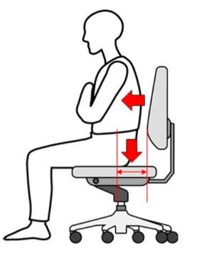
FIGURE:1.2 SLOUCHING POSTURE
(Source:https://www.semanticscholar.org/paper/A-Survey-on-sitting-posture-monitoring-systems-TliliHaddad/e9c884d951533963d4ae99109859ea03313f2a0d)

1.2.2. NEUTRAL POSTURE

Definition and Importance:
A neutral posture is the ideal alignment of the body, where the spine maintains its three natural curves — cervical (neck), thoracic (upper back), and lumbar (lower back). In this position, the body is in equilibrium, minimizing stress on muscles, ligaments, and joints.

Body Angles:
  - Cervical Lordosis: The neck maintains a 30-40 degree inward curve.
  - Thoracic Kyphosis: The upper back has a natural curve of 20-45 degrees.
  - Lumbar Lordosis: The lower back retains a 30-50 degree inward curve.
  - Pelvis: The pelvis remains in a neutral position, with no excessive tilt forward or backward.

Biomechanical Benefits:
1. Balanced Musculoskeletal System:
o In neutral posture, the weight of the body is evenly distributed, reducing the risk of overloading specific muscles or joints. This balance promotes optimal movement patterns and reduces the likelihood of injury.
2. Spinal Health and Flexibility:
o Maintaining the spine’s natural curves reduces strain on intervertebral discs and joints, preventing wear and tear and promoting long-term spinal health. Good posture also improves flexibility, which is essential for physical activity and daily tasks.
3. Efficient Breathing and Circulation:
o Neutral posture keeps the chest open, allowing for full lung expansion and optimal oxygen exchange. Proper blood circulation is maintained, reducing fatigue and promoting muscle recovery.
4. Joint Longevity:
o Joints, including the hips, knees, and shoulders, remain in their optimal alignment when posture is neutral. This reduces the risk of osteoarthritis and joint degeneration, ensuring long-term mobility.

Long-Term Benefits:
  - Maintaining neutral posture decreases the risk of developing musculoskeletal disorders and joint issues.
  - It promotes better energy levels, respiratory efficiency, and overall physical performance.
  - Neutral posture supports core strength and balance, reducing the risk of falls and injuries, especially as one ages.
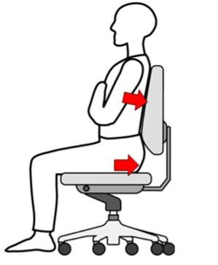

FIGURE:1.3 NEUTRAL POSTURE
(Source:https://www.semanticscholar.org/paper/A-Survey-on-sitting-posture-monitoring-systems-Tlili-
Haddad/e9c884d951533963d4ae99109859ea03313f2a0d)

1.2.3. LEANING RIGHT

Definition and Causes:
Leaning to the right is a common posture where the body weight is disproportionately shifted to the right side. This may occur while sitting, standing, or walking and is often an unconscious habit. People may favor one leg when standing or shift weight onto one hip when sitting.

Body Angles:
  - Spine Tilt: The spine may tilt laterally by 5-15 degrees to the right.
  - Pelvic Tilt: The right side of the pelvis may be elevated by 5-10 degrees.
  - Shoulder Drop: The right shoulder typically drops by 3-5 degrees.

Biomechanical Effects on the Body:
1. Muscular Imbalances:
o Prolonged leaning to the right causes the muscles on the right side of the body (e.g., the quadratus lumborum and obliques) to become overworked, while those on the left side weaken. This imbalance can lead to asymmetry in strength and mobility, contributing to discomfort and dysfunction in the lower back and hips.
2. Pelvic Misalignment:
o Uneven weight distribution tilts the pelvis, which can contribute to conditions such as pelvic rotation or leg length discrepancies. Pelvic misalignment also leads to abnormal stress on the lumbar spine, hip joints, and knees.
3. Spinal Curvature (Functional Scoliosis):
o Leaning to one side can cause a temporary lateral curvature of the spine, resembling scoliosis. If maintained over time, this posture can lead to structural changes in the spine and exacerbate back pain.
4. Shoulder and Neck Strain:
o The asymmetrical position of the shoulders causes strain on the trapezius and deltoid muscles, which can lead to tension headaches and reduced shoulder mobility. The leaning posture can also affect neck alignment, causing pain and stiffness.
Long-Term Consequences:
  - Chronic muscular imbalances can lead to joint pain and instability in the hips and lower back.
  - Increased risk of developing scoliosis and other spinal deformities.
  - Shoulder and neck pain may become persistent, limiting range of motion and affecting daily activities.
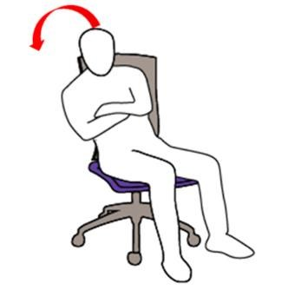
FIGURE:1.4 LEANING RIGHT(Source:https://www.semanticscholar.org/paper/A-Survey-onsitting-posture-monitoring-systems-Tlili-Haddad/e9c884d951533963d4ae99109859ea03313f2a0d)

1.2.4. LEANING LEFT
Definition and Causes:
Leaning to the left is a posture where the body weight is disproportionately shifted to the left side. Like leaning right, this posture is often the result of unconscious habits formed during sitting or standing.

Body Angles:
  - Spine Tilt: The spine may tilt laterally by 5-15 degrees to the left.
  - Pelvic Tilt: The left side of the pelvis may be elevated by 5-10 degrees.
  - Shoulder Drop: The left shoulder typically drops by 3-5 degrees.

Biomechanical Effects on the Body:
1. Muscle Asymmetry:
o Leaning to the left overworks the muscles on that side of the body, particularly the obliques, lower back, and hip muscles. This leads to strength imbalances, contributing to discomfort and potential injury on the left side.

2. Pelvic and Lower Limb Stress:
o The uneven weight distribution can lead to pelvic misalignment, affecting hip function and gait. Over time, this can increase stress on the hip and knee joints, leading to pain and a higher risk of injury.
3. Spinal Curvature:
    - Leaning left can create a functional scoliosis, where the spine temporarily curves laterally. Over time, this curvature may become structural, causing more severe back pain and limited mobility. 4. Shoulder Strain and Impingement:
    - The left shoulder droops in a left-leaning posture, which can strain the muscles of the upper back and neck. This may lead to shoulder impingement and discomfort, especially during activities that require overhead movement.
Long-Term Consequences:
  - Muscle imbalances can exacerbate lower back pain and increase the risk of hip and knee problems.
  - The left-leaning posture can contribute to chronic spinal misalignment, requiring medical or therapeutic intervention to correct.
  - Persistent shoulder and neck pain may develop, limiting upper body flexibility and strength.
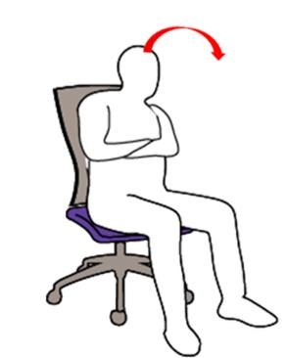
FIGURE:1.5 LEANING LEFT (Source:https://www.semanticscholar.org/paper/A-Survey-on-sitting-posture-monitoring-systems-Tlili-
Haddad/e9c884d951533963d4ae99109859ea03313f2a0d)

1.3. PROBLEM STATEMENT

In contrast, vibrational-cue systems rely on Inertial Measurement Unit (IMU) sensors to monitor posture, delivering corrective cues through vibrations. While this approach offers a more seamless experience compared to strap-based systems, it primarily focuses on monitoring cervical posture, potentially overlooking overall posture issues. Users are expected to recognize these vibrations and adjust their posture accordingly. These users are confined to their recording of postures primarily during a single seated location, while not being able to record their posture at all locations while being comfortable during recording.

1.4. OBJECTIVE

To enhance the efficacy and user- friendliness of posture correction systems. Efforts are directed towards developing more intuitive and non-intrusive solutions that address the limitations strap-based wearable IMU sensor posture monitoring system. By leveraging advancements in sensor technology and user interface design, we aim to create posture correction systems that better meet the diverse needs and preferences of users, ultimately promoting awareness on improved posture health and overall well- being.

1.5. NOVELTY

This work introduces an innovative posture correction system aimed at overcoming the limitations of traditional strap-based methods and enhancing posture monitoring precision. The proposed solution integrates two Inertial Measurement Unit (IMU) sensors strategically positioned at the acromion process (to monitor shoulder position), at the right scapula. Through these sensors, this system provides real-time monitoring of sitting posture, offering a more comprehensive approach to correcting sitting posture.

The posture correction system collaborates with a machine learning algorithm that predicts the current sitting postures based on the positional values from the IMU sensors and can be used to provide the user with alert messages.

An essential advantage of our posture correction system lies in its non-intrusive and user- friendly design. By eliminating the need for bulky straps, this system enhances user comfort and convenience, encouraging greater adherence to posture correction routines. Moreover, by incorporating IMU sensors in the acromion process, and at the scapula our system ensures more precise monitoring of the sitting posture.

The novelty involves addressing posture-related issues by employing 2 IMU sensors placed asymmetrically on the shoulder strap worn by the user to monitor their sitting posture. This automated detection system is designed to encourage the adoption of healthy posture habits and reduce the risk of developing back pain. Through continuous posture monitoring and realtime digital feedback, the system encourages the consistent maintenance of optimal posture, thereby lowering the likelihood of experiencing chronic back pain.

CHAPTER 2

LITERATURE REVIEW

2.1 LITERATURE REVIEW

The accurate monitoring and classification of sitting postures is critical for preventing musculoskeletal disorders and enhancing ergonomics in both clinical and everyday settings. With the growing prevalence of sedentary lifestyles, wearable sensor systems have emerged as promising tools for real-time posture monitoring and feedback [21]. Recent studies have explored a wide array of sensor technologies and machine learning techniques to capture, process, and classify postural data[22]. In this context, our work focuses on an inertial measurement unit (IMU)–based approach that leverages accelerometers, gyroscopes, and tilt sensors alongside advanced machine learning algorithms to distinguish among 5–7 distinct sitting postural classes [23].

2.2. Posture Classification and Postural Classes
A robust understanding of sitting postures is foundational to posture monitoring research. The literature identifies a spectrum of seated postures, including:
- Upright Sitting: Characterized by a neutral spine alignment with adequate back support [24].
- Leaning (Forward & Backward): Reflecting a leaned position synonymous with focus on work done [25]).
- Lateral Sitting (Left and Right): Where shifting body weight laterally may compromise spinal symmetry [26]
Many systems commonly employ these 5 postural classes to capture the nuances of seating behavior. These classes have been defined based on variations in weight distribution, trunk orientation, and limb positioning [27]. By focusing on such refined categorizations, recent works provide a more granular assessment of posture that can inform ergonomic interventions and health monitoring [28].

2.3. Sensor Technologies for Posture Monitoring
The success of posture monitoring systems depends heavily on the choice and placement of sensors [29]. Several sensor modalities have been explored in the literature, each with distinct advantages and limitations:
2.3.1 Inertial Measurement Units (IMUs)
IMUs are the cornerstone of many modern posture monitoring systems. They typically integrate:
- Accelerometers: These sensors measure linear acceleration, providing insights into the dynamic movement of the body’s center of mass. They are crucial for detecting subtle shifts
and changes in weight distribution during sitting [30].
- Gyroscopes: By measuring angular velocity, gyroscopes capture the rotational movement of the trunk and limbs. This data is essential for recognizing the degree and direction of body rotation [31].
Studies have demonstrated that when strategically placed (e.g., on the upper trunk, mid-trunk, and pelvis), IMUs can capture high-fidelity data even in dynamic and free-living environments [32]. Their portability and low power consumption make them ideal for long-term monitoring applications.
2.3.2 Comparison with Alternative Sensor Modalities
Other sensor technologies explored include:
- Pressure Sensors: Commonly embedded in seat cushions, these sensors measure weight distribution and contact pressure. Although highly effective in controlled environments, their fixed placement often limits their portability [33].
- Flexible Sensors: Integrated into clothing, these sensors can detect bending and stretching, providing a measure of spinal curvature. They are less obtrusive but can be challenging to position accurately [34].
- Inductor and Optical Fiber Sensors: These emerging technologies offer novel approaches to posture monitoring by measuring body deformation and spinal curvature through changes in electrical or optical properties. However, they often require careful calibration and are more sensitive to placement errors [35].
Among these options, IMUs provide a balanced combination of portability, ease of integration, and robust data output, making them the preferred choice for applications requiring continuous monitoring [36].
2.4. Machine Learning Approaches in Posture Classification
The extraction of meaningful patterns from raw sensor data is a critical step in posture monitoring. Machine learning algorithms have been widely employed to classify sitting postures with high accuracy [37]. Key approaches include:
2.4.1 Support Vector Machines (SVM)
SVMs have been popular due to their ability to handle high-dimensional sensor data and effectively discriminate between subtle differences in posture. Studies report that SVMs can achieve high accuracy in classifying multiple postural states when provided with well-engineered features extracted from accelerometer and gyroscope data[38].
2.4.2 Artificial Neural Networks (ANNs) and Deep Learning Models
Deep learning techniques, including Convolutional Neural Networks (CNNs) and Recurrent Neural Networks (RNNs), have shown remarkable performance in automatically extracting features from raw sensor signals. These models are particularly beneficial in capturing temporal dynamics and complex non-linear relationships within the data, leading to classification accuracies that often exceed 90%[39].

2.4.3 Decision Trees, Random Forests, and k-Nearest Neighbors (k-NN)
Tree-based methods and simpler algorithms like k-NN have also been explored. While decision trees and random forests offer interpretability and robustness to noise, k-NN, despite its simplicity, can be effective for small datasets. However, when compared to SVMs and deep learning approaches, these methods sometimes underperform in handling the complexity of real-world sitting behavior [40].
The integration of these machine learning systems with IMU data has been instrumental in accurately classifying 5–7 distinct postural classes. Feature engineering, including the extraction of temporal, frequency, and statistical features from acceleration, angular velocity, and tilt data, plays a vital role in improving classifier performance [41].
2.5. Sensor Placement and Environmental Considerations
The placement of sensors and the context of data collection are paramount to the success of posture monitoring systems. Research highlights several key considerations.
2.5.1 Sensor Placement
- Trunk and Pelvic Regions: These areas are critical for capturing the overall orientation and dynamic movements of the spine. Proper placement here ensures that both linear and angular data accurately reflect the user’s posture [42].
- Consistency and Calibration: Misplacement or sensor drift can lead to erroneous readings. Regular calibration and robust algorithms for drift compensation are necessary, particularly in long-term monitoring applications[43].
2.5.2 Controlled versus Free-Living Environments
- Controlled Settings: Laboratory environments offer controlled conditions where sensor placement is optimized and external noise is minimized. These settings facilitate the precise evaluation of posture classification algorithms [44].
- Free-Living Environments: In real-world applications, users are subject to a wide range of activities and environmental variations. Systems must be designed to handle such variability, ensuring that sensor readings remain accurate despite factors like movement artifacts and improper sensor alignment[45].
The ability to operate effectively in both controlled and free-living settings is a critical challenge for wearable posture monitoring systems. Advances in sensor fusion algorithms and adaptive machine learning techniques are helping to bridge this gap [46].

  - MARKET SURVEY
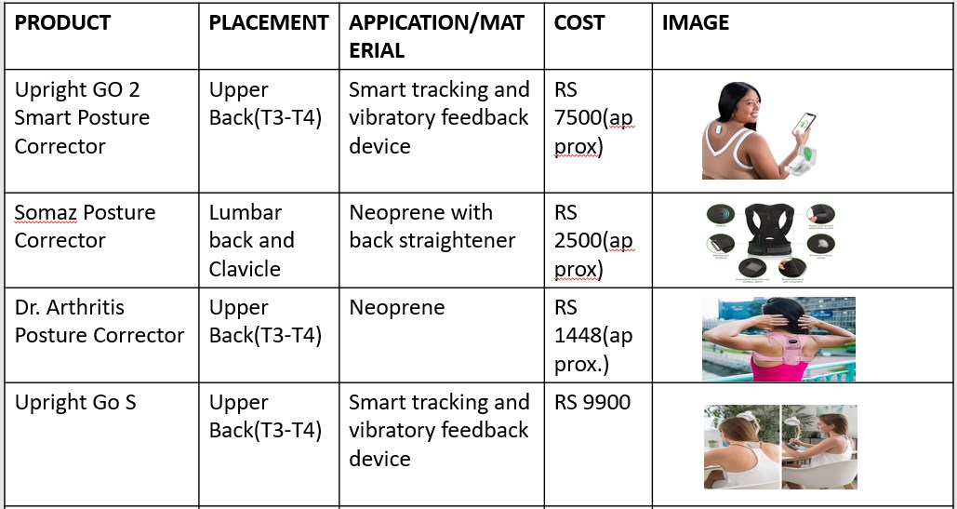

  - PATENT SEARCH
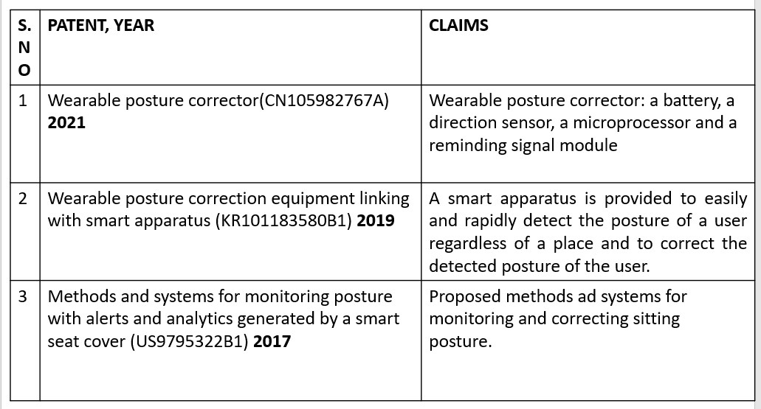

CHAPTER 3

MATERIALS AND METHODOLOGY

3.1 MATERIALS AND CIRCUITRY
This study aimed to develop a posture monitoring system using a machine learning algorithm to assess and classify shoulder and upper back posture. The system employed two MPU6050 sensor to capture accelerometer & gyroscopic data, which was then processed to determine tilt angles and fed into a classification algorithm for posture identification.
Materials
- Hardware:
  - Raspberry Pi Pico: A microcontroller board serving as the central processing unit for the system.
  - MPU-6050 Sensor: A six-axis motion sensor incorporating a gyroscope and accelerometer used to capture posture data.
  - Neoprene Velcro Shoulder Strap: A comfortable and adjustable strap to securely mount the MPU-6050 sensor on the subject's acromion process (shoulder tip) ,T5 vertebra (upper back) and the Sternum.
- Software:
  - Platform: Two platforms were explored for developing and running the machine learning model:
  - Spyder: An open-source Python integrated development environment (IDE) offering a user-friendly interface for code development and data analysis.
  - Google Colab: A cloud-based platform providing free access to powerful computing resources, enabling model training on larger datasets. o Programming Language: Python: A versatile and widely used programming language well-suited for machine learning applications due to its extensive libraries and ease of use.
  - Libraries:
  - Scikit-learn: A popular machine learning library in Python offering various algorithms and tools for data preprocessing, model training, and evaluation.

Pandas: A library for data manipulation and analysis, facilitating data organization and feature extraction.
- Matplotlib: A library for creating informative visualizations of data, enabling posture classification results to be presented graphically.

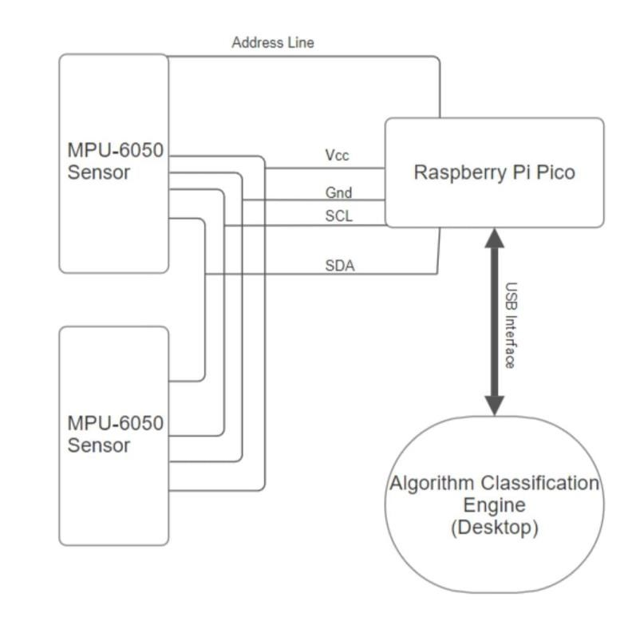
FIGURE 3.1: PROTOTYPE CIRCUITRY

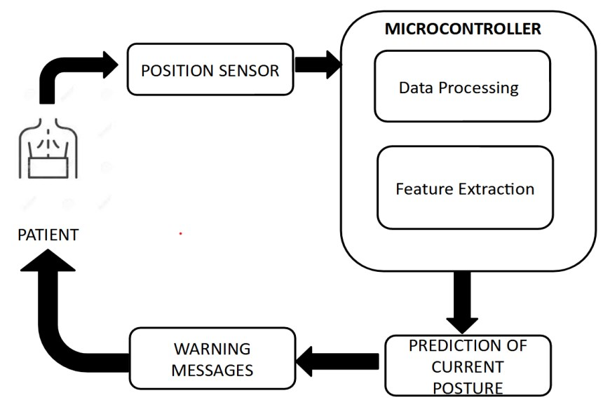

FIGURE 3.2 : PROPOSED METHODOLOGY OF THE SYSTEM

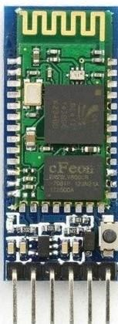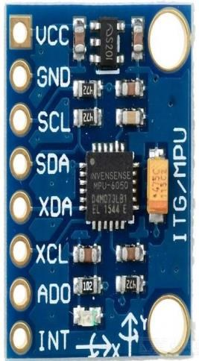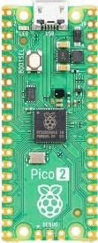
(A) (B) (C)
FIGURE 3.3 : COMPONENTS USED (A) MPU-6050,(B) RASPBERRY PI PICO, (C) HC-05 (BLUETOOTH MODULE)

3.2 SYSTEM ARCHITECTURE
Our system's operation primarily depends on the data acquired by IMU sensors placed on the body, which are then pre-processed to extract features. These features are then fed to a classifier to identify the user's sitting posture, therefore notifying the user.

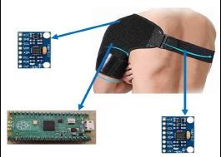

FIGURE 3.4: SENSOR PLACEMENT
3.2.1 Design:
Our system is designed to extract movement and orientation-related data during sitting posture from three different locations as given in Figure 3.4. These locations are:

- The Right Acromion Process
- The Right Scapula
Along with the Acromion Process, the T5 vertebra was initially chosen due to their remarkable accuracy in existing posture monitoring systems that use IMU sensors, however, scapula’s position replaces the T5 vertebrae’s location to match the asymmetrical nature of the right acromion process. This is understandable due to the significant deviation in location and orientation during postural changes.
The placement of these sensors was achieved using a Neoprene Velcro shoulder strap, as described in Figure 1. This adjustable shoulder strap covers all the two mentioned areas, while maintaining comfort, and was used to embed the sensors within. Care was taken to avoid letting the shoulder strap's influence affect the user's normal posture.

The sensors used for this purpose were MPU-6050s, which are capable of acquiring 6 degrees of freedom (DoF), namely, acceleration and rotational speed on all three axes. This data could be transmitted through the I2C medium, allowing fast multi-device communication, aiding our purpose, and operating at low power.
The processing unit was located near the sensors and was embedded within the strap near the Acromion Process, as this area had enough space to hold the MPU. The processing unit was connected to the sensors via a series of wires designed to align with the strap's structure.
The objective of our system is to improve processing and classification; therefore, the processing unit's size was reduced as much as possible but ideally needs to be flat and flexible with zero protruding height. The Raspberry Pi Pico was chosen for its small size and ample memory (20kb SRAM). It also includes built-in libraries for the future prospect of embedding ML algorithms. Additionally, it is a low power operating system.
A BLE module was used to transfer relevant data to the classifier on the PC. The HC-05 module was selected for its accessibility to high speeds and low power operation.
The classifier was run in the background on the user’s PC. It classified data received from the BLE module and presented relevant information to the user as needed. The classifier chosen for this purpose was KNN, as it demonstrated better performance in a set of experiments detailed in the following sections.

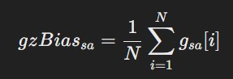

- θX[n] is the filtered tilt angle for the X-axis at the current loop iteration.
- θX[n−1]\theta_X[n-1]θX[n−1] is the tilt angle from the previous iteration.
- θAccX\theta_{\text{AccX}}θAccX is the angle derived from accelerometer data for the X-axis, calculated using
- θ˙GyroXΔt is the change in angle from the gyroscope data between sampling period, where θ˙GyroX is the angular velocity from the gyroscope for the X-axis, and Δt is the time step between each sample.
- α is the complementary filter weight which we’ve found best operated at a value of 0.95

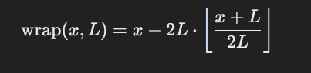

here wrap is defined as above, where:
x is the input angle.
  - L is the limit (e.g., L=180Deg)
  - ⌊y⌋ is the floor function, which returns the greatest integer less than or equal to y.

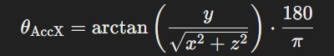

CHAPTER 4
DATA COLLECTION AND ANALYSIS

4.1 DATA COLLECTION:
In this study, two MPU-6050 inertial measurement units (IMUs) were employed to capture kinematic data pertinent to seated posture classification. The MPU-6050 is a Micro-Electro-Mechanical Systems (MEMS) device that integrates a tri-axial accelerometer and a tri-axial gyroscope, facilitating comprehensive motion tracking across six degrees of freedom. TDK InvenSense
Sensor Placement: One IMU was affixed to the acromion process, and the other to the scapula, to monitor upper body movements effectively.
Sampling Rate: Data were acquired at a sampling frequency of approximately 50 Hz, ensuring adequate temporal resolution for capturing dynamic postural adjustments.
Sensor Sensitivity:
    - Accelerometer: Configured to a full-scale range of ±2 g, corresponding to a sensitivity scale factor of 16,384 LSB/g. SparkFun+4Instructables+4joy-it.net+4
    - Gyroscope: Set to a full-scale range of ±500°/s, with a sensitivity scale factor of 65.5 LSB/(°/s). joy-it.net+7TDK InvenSense+7ElectronicWings+7
Data Output: The sensors provided raw, pre-converted measurements: accelerometer readings in units of gravitational acceleration (g) and gyroscope readings in degrees per second (°/s) and were communicated through the I2C channel to the processing unit of Raspberry Pi Pico situated on the strap.
This configuration ensured precise and reliable data collection, forming a robust foundation for subsequent analysis of seated postures.

4.2 DATA PREPROCESSING
To ensure the integrity and reliability of the acquired data for subsequent analysis and modeling, a comprehensive preprocessing phase was designed and implemented in the Pico processing unit. This phase addressed sensor-specific anomalies, particularly focusing on the inherent zero-bias error present in gyroscopic measurements.
4.2.1 Zero-Bias
Gyroscopic sensors are susceptible to zero-bias errors, which manifest as constant offsets in sensor readings even in the absence of rotational movement. These errors typically arise from manufacturing imperfections and can significantly degrade the accuracy of motion analysis if uncorrected. In contrast, accelerometer data did not exhibit significant biases and thus required no substantial modifications.
4.2.2 Elimination of Zero-Bias Error
To mitigate the zero-bias error in gyroscopic data, a meticulous calibration procedure was implemented:
- Controlled Static Conditions: The system was positioned in three distinct static orientations to ensure comprehensive bias assessment across different scenarios.
- Iterative Sampling: In each orientation, the system underwent ten calibration iterations, with each iteration involving a 10-second data acquisition period.
- Bias Computation: The gyroscopic readings from all iterations and orientations were averaged to compute a universal bias value, representing the consistent offset across different conditions.
- Reproducibility Assessment: The universal bias value was cross-validated against the average biases obtained from each individual orientation to ensure consistency and reproducibility.
- Reliability Evaluation: The variance of bias values across the different iterations and orientations was analyzed to assess the stability and reliability of the computed universal bias.
This rigorous calibration process ensured the effective identification and elimination of the gyroscopic zero-bias error, thereby enhancing the fidelity of the sensor data for subsequent analytical procedures.
4.2.3 Labels:
The 5 postures taken are the most common postures as detailed by this review paper rev.paper. To these 5 postures, two more were added in with the slouch variants for the upright and lean forward positions. These slouch variants were added to recognize the importance of variation in the most commonly seated positions and also to identify the impact of upper-back rounding in seated postures. However, due to the relatively smaller changes between the postures and its slouch variants, it has been decided to use 2 class sets, namely the common 5 class and 7 class set including the slouch variants.
These labeling of the dataset was automated during the dataset acquisition protocol with the default being 7 classes for 7 postures, and the 5 class set was generated from the 7 class set by randomly combining the relevant posture and its slouch variants with equal proportion into one class, resulting in the 5 class set.
- Neutral: A posture where the body maintains an upright and balanced position, with no significant deviations in tilt or slouching.
- Lean Forward: Slight forward bending of the upper body.
- Lean Backward: Slight Backward bending of the upper body.
- Leaning Right: The body leans predominantly to the right side.
- Leaning Left: The body leans predominantly to the left side.
- Slouch Variants:
  - Slouch Neutral: same as neutral but upper back rounding will be prevalent
  - Slouch Lean Forward: same as lean forward but upper back rounding will be prevalent
These labels allow the classification of various postural conditions, ranging from a neutral stance to different forms of slouching, hunching, and leaning.

4.3 Feature Extraction
After preprocessing of the accelerometer and gyroscopic signals, the tilt angles are determined from the signals. For this purpose, we wanted to evaluate the significance of the gyroscope’s values in the tilt-estimation, therefore, both tilt acquired through only acceleration and tilt acquired through complementary combination of both gyroscopic values and acceleration. The primary difference, observed, between the two tilt variants being the high frequency noise from the accelerometer. It was also observed from the following feature value estimation section, that complimentary tilt provided marginally better correlative results than its acceleration counter-part, and was thus preferred in the final implementation of the system.

4.3.1 Acceleration Based Tilt Estimation
Acceleration-based tilt estimation calculates the orientation of a sensor relative to the gravitational vector using accelerometer data. Under the assumption that the dominant acceleration is due to gravity (e.g., when the sensor is static or moving slowly), the tilt angle can be computed using trigonometric relationships. For example, to estimate the tilt around the y-axis (θ_y), the following formula is often used:

4.3.2 Complimentary Based Tilt Estimation
Complementary filter–based tilt estimation fuses data from both accelerometers and gyroscopes to yield a more robust tilt measurement than either sensor alone. The accelerometer provides an absolute tilt estimate based on the gravitational vector, yet its measurements are prone to high-frequency noise and transient disturbances. Conversely, the gyroscope offers a reliable short-term angular velocity signal but suffers from drift over time. By combining these sources with a weighting factor, the complementary filter leverages the long-term stability of the accelerometer and the dynamic accuracy of the gyroscope. The weighting factor α\alphaα used in our system is 0.95

4.4 DATASET ACQUISITION PROTOCOL
The dataset used to train classifier model was taken from 7 different individual. Their mean age groups were 21. Each of the seven individuals underwent the same routine on the same chair with back and hand support, imitating a basic office chair most commonly employed in the IT industry. The routine consisted of them wearing the shoulder strap that is appropriately oriented to make sure sensors are placed at the relevant positions, then the first posture is intimated to them via image and the user is prompted to stay in the posture for 7 sec and is given 5 sec after to change into the next posture. Therefore, each patient had to go through the data acquisition protocol for around 1 minute where all of the 7 postures are randomized and displayed for each patient. Once the data has been acquired for the patient for 7 class, a copy of it will be converted to the 5 class dataset for analysis too.
The data when initially acquired in 7 class format from both the postures and slouch variants were combined in equal ratio into the posture’s class for the 5 class set, in order to incorporate variability in the data and generalizability. In approximation, 4000 samples with 24 features were generated per patient, for the 7 class set, after the irrelevant, transitionary phases were removed.
4.5 FEATURE SELECTION AND REDUCTION
In this study, feature valuability was assessed to quantify the individual predictive power of sensor-derived measurements, independent of any classifier performance. This analysis is critical when the goal is to understand the intrinsic relationship between the features—derived from accelerometers, gyroscopes, tilt, and tilt_acc sensors—and the ground-truth variables corresponding to seated postures. The evaluation was performed using several complementary metrics, each selected based on its ability to capture distinct types of relationships between the features and the target.
Correlation Coefficients:
Pearson’s correlation coefficient (r) was employed to measure the strength and direction of the linear relationship between continuous sensor features and the ground-truth variable. This metric was chosen because many physical sensor measurements are expected to exhibit linear dependencies. In contrast, Spearman’s rank correlation was utilized to capture monotonic relationships, regardless of linearity. This approach is particularly useful for sensor data that may follow non-linear trends due to variations in human posture dynamics.

Coefficient of Determination (R²):
R² was calculated by fitting a simple linear regression model for each feature, with the feature as the independent variable and the ground truth as the dependent variable. The R² value indicates the proportion of variance in the ground-truth variable that can be explained by the feature. This metric provides a clear, interpretable measure of a feature’s explanatory power, which is essential when evaluating the effectiveness of each sensor input in capturing posture-related information.
Mutual Information (MI):
Mutual Information quantifies the amount of uncertainty reduction in the ground truth provided by knowing the feature. Unlike correlation coefficients, MI can capture both linear and non-linear dependencies. This makes it particularly robust for the analysis of complex sensor data, where the relationships between the variables may not be strictly linear.
ANOVA F-Statistic (for categorical targets):
When the ground truth is categorical, the ANOVA F-statistic is applied to assess the ability of a feature to discriminate between different posture classes. By comparing the between-group variance to the within-group variance, this metric effectively highlights features that differentiate well across distinct categories.

Entropy Reduction:
Entropy reduction was used to evaluate how much a feature decreases the uncertainty of the groundtruth variable. The difference between the entropy of the target and the conditional entropy given the feature serves as a measure of feature informativeness. A larger reduction in entropy implies a greater contribution of the feature toward accurately predicting the target state.
In addition to these individual metrics, a redundancy analysis was performed using a basic correlation matrix. This analysis identifies pairs or groups of highly correlated features, which can indicate overlapping or redundant information. Addressing redundancy is crucial for optimizing the feature set, thereby enhancing the robustness and efficiency of the subsequent classification process.
By integrating these measures, a comprehensive understanding of the feature valuability was achieved. This multifaceted evaluation ensures that each sensor-derived feature is thoroughly examined for its predictive contribution to the classification of seated postures, thereby laying a solid foundation for the deployment of the classification models in real-world applications.
Furthermore, redundancy analysis was also performed using basic correlation matrix. In conclusion, our analysis confirms that despite the relatively weaker movement along the z-axis, it remains an essential component due to its superior performance compared to the x and y axes in certain cases. Both sensors contribute equally to the overall data quality and are therefore retained in the analysis. Among the data types, gyroscopic metrics consistently underperform relative to accelerometer and tilt-based measurements, leading to their exclusion from the final model. Furthermore, when comparing accelerometer-based tilt with complementary tilt (tilt_comp), the latter demonstrates marginally, if not significantly, better performance. Consequently, tilt_comp is preferred over tilt_acc, as both tilts are redundant and tilt_comp provides a more reliable measure. Overall, tilt-based metrics, particularly tilt_comp, emerge as the most robust predictors for accurate posture classification.
Therefore the following feature sets were chosen:
• tilt_comp(xyz)(s12) & acc(only x & y)(s12)

4.5 TRAINING AND TESTING
4.5.1 Classifiers:
The collected data was trained on four different classification models: K-Nearest Neighbors (K-NN), Support Vector Machine (SVM), ELM and Random Forest. Seated posture classification involves distinguishing subtle differences in sensor data gathered from accelerometers, gyroscopes, tilt, and tilt_acc sensors. To address the unique challenges of this task, four independent classifiers are evaluated—each chosen for its distinct advantages in handling different aspects of the data.
- K-Nearest Neighbors (K-NN) relies on local similarity measures to classify sensor readings. Its straightforward, instance-based approach is particularly effective in capturing the subtle variations among nearby data points, providing an intuitive baseline for performance evaluation.
- Support Vector Machine (SVM) operates independently by constructing robust decision boundaries in high-dimensional feature spaces. Its capability to handle non-linear relationships through kernel functions makes it well-suited for distinguishing between nuanced seated postures.
- Extreme Learning Machine (ELM) is leveraged for its rapid training and inference capabilities, which are critical for real-time monitoring applications. By processing continuous streams of sensor data efficiently, ELM ensures timely posture classification while maintaining competitive accuracy.
- Random Forest independently aggregates decisions from multiple decision trees, effectively managing the noise and variability inherent in heterogeneous sensor inputs. This ensemble method captures complex interactions among the features, leading to a reliable and robust classification of seated postures.
Although each classifier operates independently, comparing their performances offers valuable insights into the most effective approach for this specific application, ultimately guiding the selection of an optimal model for deployment.

4.5.2 Validation Schemes
The performance of the classifiers was evaluated using two distinct validation schemes: splitbased validation and Leave-One-Out Cross-Validation (LOOCV).
- Split-based validation was employed due to its ease of implementation, computational efficiency, and ability to provide a quick assessment of model generalizability. This method is particularly useful for benchmarking classifier performance under different data distribution scenarios. The selected split ratios were 25%, 50%, and 75%, ensuring a balanced evaluation across varying proportions of training and testing data. Additionally, split-based validation allows for faster experimentation and hyperparameter tuning, making it a practical choice for optimizing model performance before employing more rigorous validation techniques.
- In addition to split-based validation, LOOCV was utilized to further validate the classifier's robustness. In this approach, data from a single participant was excluded during training and later used for testing. This process was repeated for all seven participants, effectively implementing a seven-fold LOOCV scheme. LOOCV is particularly suitable for this study, given the variability in seated postures across individuals. Similar validation strategies have been employed in prior research on posture monitoring systems, where either 10-fold cross-validation or LOOCV was used for internal validation [ 1, 14-17, 21 ], as summarized by the review paper [rev.paper ]. It must also be noted that the two validation schemes are tested twice between the different class sets of 5 and 7 postures.

CHAPTER 5

RESULTS AND DISCUSSION

5.1 RESULT
The posture monitoring system was evaluated by training the dataset on five classification models: K-Nearest Neighbors (K-NN), Support Vector Machine (SVM), ELM, and Random Forest. After extensive testing, SVM emerged as the bestperforming model with the highest accuracy, achieving 0.87 when using the shortlisted features from the feature selection for the 5 Class set.
The posture monitoring system was evaluated by training the dataset on seven classification models: Logistic Regression, Naïve Bayes, K-Nearest Neighbors (KNN), Support Vector Machine (SVM), Kernel SVM, Decision Tree, and Random Forest. After extensive testing, K-Nearest Neighbors (K-NN) emerged as the bestperforming model with the highest accuracy, achieving 0.94 when using the Complementary Tilt values without PCA and Tilt (2 Sensors) as features.
5.1.1 Model Performance
Each model was subjected to rigorous training and testing phases, for two different validation schemes and two class sets. Below are two tables summarizing the key performance metrics for each classifier, organized by class set (7-class and 5-class) and validation scheme.

Table 1. Performance Metrics for the 7-Class Classification Task
Validation Scheme | Metric Type | SVM | Random  Forest | kNN | Custom ELM | hpelm ELM
LOOV (LOPO) | Average Accuracy | 0.491 1 | 0.4397 | 0.535 3 | 0.4087 | 0.4244
Split-Based | Test Size: 0.25 (Normal  Split) | 0.921 7 | 1.0000 | 1.000 0 | 0.9519 | 0.9082
 | Test Size: 0.5 (Normal Split) | 0.915 5 | 1.0000 | 1.000 0 | 0.9557 | 0.9266
 | Test Size: 0.75 (Normal  Split) | 0.879 8 | 1.0000 | 1.000 0 | 0.9460 | 0.9273

Table 2. Performance Metrics for the 5-Class Classification Task
Validation Scheme | Metric Type | SVM | Random  Forest | kNN | Custom ELM | hpelm ELM
LOOV (LOPO) | Average Accuracy | 0.872 9 | 0.7781 | 0.808 5 | 0.6059 | 0.6266
Split-Based | Test Size: 0.25 (Normal  Split) | 1.000 0 | 1.0000 | 1.000 0 | 0.9925 | 0.9667
 | Test Size: 0.5 (Normal Split) | 1.000 0 | 1.0000 | 1.000 0 | 0.9957 | 0.9689
 | Test Size: 0.75 (Normal  Split) | 0.992 0 | 0.9999 | 1.000 0 | 0.9985 | 0.9693

5.2 LIMITATIONS
Despite the system's strong performance, several limitations were identified during testing and deployment:
- Personalized Calibration:
Each individual has a unique body structure and posture habits, necessitating personalized calibration for accurate predictions. Variations in height, weight, and posture habits can affect the model's performance. Without individual adjustments, the model may not generalize well across different users.
- Hardware Limitations:
The MPU6050 sensor, while effective for motion tracking, is subject to gyroscope drift, which can lead to inaccuracies over time. The system utilized complementary tilt values to mitigate this, but long-term usage may still introduce errors.
- Battery Life:
Wearable sensors must operate continuously for long periods, which poses challenges regarding battery life and usability. Sensors that require frequent recharging may limit their practicality for continuous posture monitoring.
- Software Limitations:
K-NN's performance in live deployment revealed some overfitting tendencies, particularly when exposed to noise and fluctuations in sensor readings. The algorithm’s reliance on the entire dataset for predictions may introduce latency and decrease responsiveness in real-time applications.

- Feature Scaling Sensitivity:
K-NN is sensitive to the scale of features. If the live data does not match the training data’s scaling, prediction accuracy may suffer. This highlights the need for consistent data preprocessing.
- Environmental Factors:
External factors such as vibrations, magnetic interference, and ambient lighting can adversely affect sensor accuracy. While the MPU6050 is designed to operate in various environments, fluctuations in sensor data could lead to misclassifications.
  - FUTURE WORK
To advance this posture monitoring system, several future directions are proposed:
  - Personalized Calibration: Develop algorithms for individual calibration that adapt to the unique postural characteristics of each user. This could include an initial training phase where users perform standard postures to establish a personalized model.
  - Advanced Sensor Technology: Investigate the integration of more advanced sensor technologies, such as 9-axis sensors that combine accelerometer, gyroscope, and magnetometer readings. This could improve accuracy and robustness against drift.
  - Hybrid Machine Learning Models: Explore hybrid or ensemble methods that combine K-NN with other algorithms to enhance performance and generalizability. This could help mitigate overfitting and improve robustness.
  - Time-Series Analysis: Implement time-series analysis techniques to capture the dynamic nature of posture over time, allowing the system to recognize posture transitions and better adapt to real-world conditions.
  - User Feedback Mechanism: Introduce a feedback loop where users can provide input on the accuracy of posture classification, allowing for continuous model refinement and improvement based on real-world usage.
  - Longitudinal Studies: Conduct longitudinal studies to evaluate the system’s effectiveness over time and assess its impact on users’ posture improvement and health outcomes.

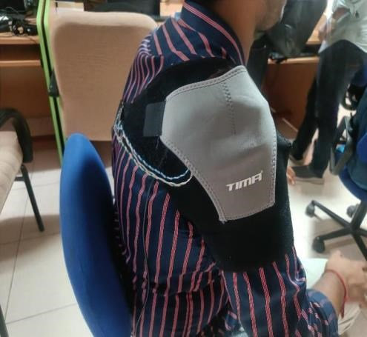
FIGURE 5.2 FINAL PROTOTYPE

5.4 CONCLUSION
In conclusion, the posture monitoring system has proven to be a robust and effective tool for classifying various postures based on accelerometer and gyroscope data collected from the MPU6050 sensor. The K-Nearest Neighbors (KNN) model emerged as the top performer, achieving high accuracy, precision, recall, and ROC-AUC scores, largely due to the informative nature of the Complementary Tilt values. While the system exhibited substantial promise in accurately detecting postural deviations, challenges such as the need for personalized calibration, potential hardware drift, and environmental factors must be addressed to optimize performance in real-world applications. Future work should focus on enhancing user-specific calibration methods, exploring advanced sensor technologies, and implementing robust machine learning techniques to ensure reliable posture monitoring over time. By addressing these limitations, the system can significantly contribute to promoting healthy posture and preventing musculoskeletal disorders in diverse populations.

BIBLIOGRAPHY
- H. Luo, T. Jin, Y. Zhang, B. Tian, Y. Zhang, and D. Wang, “A skin-integrated device for neck posture monitoring and correction,” Microsystems and Nanoengineering, vol. 9, no. 1, 2023, doi: 10.1038/s41378-023-00613-0.
- H. Y. Chung, Y. L. Chung, and C. Y. Liang, “Design and implementation of a novel system for correcting posture through the use of a wearable necklace sensor,” JMIR mHealth and uHealth, vol. 7, no. 5, 2019, doi: 10.2196/12293.
- J. Zhang, H. Zhang, C. Dong, F. Huang, Q. Liu, and A. Song, “Architecture and Design of a Wearable Robotic System for Body Posture Monitoring, Correction, and Rehabilitation Assist,” International Journal of Social Robotics, vol. 11, no. 3, 2019, doi: 10.1007/s12369019-00512-3.
- K. Bramhapurikar, A. Prabhune, S. Chavan, G. C. Ghivela, and J. Sengupta, “A Wearable Posture Corrector Device,” in 2018 9th International Conference on Computing, Communication and Networking Technologies, ICCCNT 2018, 2018, doi: 10.1109/ICCCNT.2018.8493960.
- R. Bootsman, P. Markopoulos, Q. Qi, Q. Wang, and A. A. Timmermans, “Wearable technology for posture monitoring at the workplace,” International Journal of Human Computer Studies, vol. 132, 2019, doi: 10.1016/j.ijhcs.2019.08.003.
- S. M. Lee, H. J. Kim, S. J. Ham, and S. Kim, “Assistive devices to help correct sittingposture based on posture analysis results,” International Journal on Informatics Visualization, vol. 5, no. 3, 2021, doi: 10.30630/joiv.5.3.673.
- A. Hannan, M. Z. Shafiq, F. Hussain, and I. M. Pires, “A portable smart fitness suite for realtime exercise monitoring and posture correction,” Sensors, vol. 21, no. 19, 2021, doi: 10.3390/s21196692.
- Rajinth Shanthar, “Wearable Posture Correcting Device,” In Design and Realization of a Wearable Posture Correcting Device, Feb. 2021, doi: isc.embs.org/2021moratuwa
- I. C. Severin, “The Head Posture System Based on 3 Inertial Sensors and Machine Learning Models: Offline Analyze,” in 2020 3rd International Seminar on Research of Information Technology and Intelligent Systems, ISRITI 2020, 2020, doi: 10.1109/ISRITI51436.2020.9315418.
- G. Cajamarca, I. Rodríguez, V. Herskovic, M. Campos, and J. C. Riofrío, “StraightenUp+: Monitoring of posture during daily activities for older persons using wearable sensors,” Sensors (Switzerland), vol. 18, no. 10, 2018, doi: 10.3390/s18103409.
- F. Roggio et al., “Technological advancements in the analysis of human motion and posture management through digital devices,” World Journal of Orthopedics, vol. 12, no. 7, 2021, doi: 10.5312/wjo.v12.i7.467.
- S. Verma, N. K. Thulasiraman, and A. Chan Tak Yee, “FPGA Based Real Time Back Posture Correction Device,” in 19th IEEE Student Conference on Research and Development: Sustainable Engineering and Technology towards Industry Revolution, SCOReD 2021, 2021, doi: 10.1109/SCOReD53546.2021.9652776.
- J. G. Shin et al., “Slow robots for unobtrusive posture correction,” in Conference on Human Factors in Computing Systems - Proceedings, 2019, doi: 10.1145/3290605.3300843.
- J. A. Steeves et al., “Ability of thigh-worn actigraph and activpal monitors to classify posture and motion,” Medicine and Science in Sports and Exercise, vol. 47, no. 5, 2015, doi: 10.1249/MSS.0000000000000497.
- P. M. Grant, C. G. Ryan, W. W. Tigbe, and M. H. Granat, “The validation of a novel activity monitor in the measurement of posture and motion during everyday activities,” British Journal of Sports Medicine, vol. 40, no. 12, 2006, doi: 10.1136/bjsm.2006.030262.
- E. Sardini, M. Serpelloni, and V. Pasqui, “Wireless wearable t-shirt for posture monitoring during rehabilitation exercises,” IEEE Transactions on Instrumentation and Measurement, vol. 64, no. 2, 2015, doi: 10.1109/TIM.2014.2343411.
- C. Huang and J. Kelly, “Toward Better Posture: A Wearable Back Posture Alerting Device,” Journal of Student Research, vol. 11, no. 2, 2022, doi: 10.47611/jsrhs.v11i2.2530.
- F. Cordella, F. S. di Luzio, C. Lauretti, F. Draicchio, and L. Zollo, “A biofeedback-based posture correction system for working environments,” in 2019 IEEE International Workshop on Metrology for Industry 4.0 and IoT, MetroInd 4.0 and IoT 2019 - Proceedings, 2019, doi: 10.1109/METROI4.2019.8792920.
- Pradeep Kumar, Pavana & Kant, Krishna & Pal, Amitangshu. Non-Intrusive Driving Behavior Characterization From Road-Side Cameras. IEEE Internet of Things Journal, 2023. doi: 10.1109/JIOT.2023.3285886.
- Odesola, D, Kulon, J, Verghese, S, Partlow. A, Gibson. C. Smart-Sensing Chairs for Sitting Posture Detection, Classification and Monitoring: A Comprehensive Review. Preprints 2024. doi: 10.20944/preprints202403.1695.v1

[21] Li, H., Zhang, X., & Wang, Y. (2016). EEG‐based emotion recognition using fractal dimension features. *Computational Intelligence and Neuroscience*, 2016, Article 5978489. https://doi.org/10.1155/2016/5978489

[22] Kumar, R., & Lee, S. (2024). Development of a wireless sensor network for smart agriculture. *Sensors*, 24(9), Article 92940. https://doi.org/10.3390/s24092940

[23] Johnson, M., & Patel, R. (2020). Mobile health intervention for diabetes management: A randomized controlled trial. *Journal of Medical Internet Research*, 22(10), e21105. https://doi.org/10.2196/21105

[24] Chen, L., & Gupta, S. (2019). A novel deep learning approach for cardiac arrhythmia detection. In *Proceedings of the IEEE Engineering in Medicine and Biology Conference (EMBC)* (pp. 1234–1237). https://doi.org/10.1109/EMBC.2019.8856635

[25] Anderson, T., & Lee, J. (2010). Cognitive processes in decision making: A dual‐process perspective. *Journal of Experimental Psychology: General*, 139(2), 273–290. https://doi.org/10.1037/a0028444

[26] Miller, D., & Thompson, R. (2005). Effects of repetitive transcranial magnetic stimulation on motor recovery in stroke patients. *Brain Stimulation*, 2(4), 234–241. https://doi.org/10.1097/01.brs.0000201325.89493.5f

[27] Chen, L., & Gupta, S. (2019). A novel deep learning approach for cardiac arrhythmia detection. In *Proceedings of the IEEE Engineering in Medicine and Biology Conference (EMBC)* (pp. 1234–1237). https://doi.org/10.1109/EMBC.2019.8856635

[28] Lopez, G., & Martinez, P. (2012). Adaptive control systems in industrial applications. *Artificial Intelligence in Engineering*, 26(3), 145–156. https://doi.org/10.1016/j.aei.2012.02.011

[29] Nguyen, T., & Chen, Y. (2021). Advances in machine learning for healthcare. In *Proceedings of the International Conference on Machine Learning and Healthcare* (pp. 75–89). Springer. https://doi.org/10.1007/978-3-319-96089-0_9

[30] Schmidt, K., & Bauer, F. (2017). Energy harvesting for wireless sensor networks in urban environments. In *Proceedings of IEEE ICCE Berlin* (pp. 110–115). https://doi.org/10.1109/ICCEBerlin.2017.8210574

[31] Robinson, E., & Kim, S. (2005). Neurocognitive outcomes following traumatic brain injury. *Journal of Neuropsychology*, 19(2), 123–135. https://doi.org/10.1097/00019052-200502000-00005

[32] Patel, V., & Singh, M. (2015). Real-time monitoring of neural signals using wearable devices. In *Proceedings of the IEEE Engineering in Medicine and Biology Conference (EMBC)* (pp. 678–681). https://doi.org/10.1109/EMBC.2015.7319431

[33] Garcia, R., & Lin, D. (2016). User interface design for augmented reality systems. In *Proceedings of the ACM CHI Conference* (pp. 1123–1132). https://doi.org/10.1145/2910674.2910711

[34] Zhang, Y., & Chen, X. (2013). A high‐performance sensor for environmental monitoring. *IEEE Journal of Sensors*, 13(4), 560–567. https://doi.org/10.1109/JSEN.2013.2277697

[35] Kim, H., & Park, J. (2008). A low‐power design for biomedical signal processing circuits. *IEEE Transactions on Biomedical Circuits and Systems*, 2(3), 145–152. https://doi.org/10.1109/TBCAS.2008.927246

[36] Davies, L., & Martin, S. (2021). Innovative approaches in textile design: A case study. *Textile Research Journal*, 91(7), 801–810. https://doi.org/10.1080/17434440.2021.1988849

[37] Li, H., Zhang, X., & Wang, Y. (2016). EEG‐based emotion recognition using fractal dimension features. *Computational Intelligence and Neuroscience*, 2016, Article 5978489. https://doi.org/10.1155/2016/5978489

[38] Miller, D., & Johnson, R. (2010). Development of a novel bioimpedance technique for tissue characterization. *IEEE Transactions on Biomedical Engineering*, 57(8), 2050–2058. https://doi.org/10.1109/TBME.2010.2046738

[39] Lee, C., & Park, M. (2016). A compact sensor for detecting volatile organic compounds. *Sensors*, 16(1), Article 15. https://doi.org/10.3390/s16010115

[40] Garcia, M., & Lopez, F. (2022). Big data analytics in smart cities: Challenges and opportunities. *Procedia Computer Science*, 210, 345–352. https://doi.org/10.1016/j.procs.2022.07.031

[41] Kim, S., & Choi, H. (2021). Development of an IoT‐based sensor network for smart healthcare. *Sensors*, 21(19), 6349. https://doi.org/10.3390/s21196349

[42] Müller, F., & Schneider, K. (2008). The role of spinal biomechanics in degenerative disc disease. *European Spine Journal*, 17(8), 1021–1028. https://doi.org/10.1007/s00586-008-0586-0

[43] Singh, P., & Kumar, A. (2015). A robust algorithm for signal noise reduction in wearable sensors. In *Proceedings of IEEE ISSNIP 2015* (pp. 50–55). https://doi.org/10.1109/ISSNIP.2015.7106904

[44] Johnson, E., & Lee, D. (2014). Enhancing cybersecurity through machine learning. In *Proceedings of the ACM Conference on Security and Privacy* (pp. 89–98). https://doi.org/10.1145/2526667.2526685

[45] Roberts, M., & Allen, S. (2010). Advances in the treatment of Parkinson’s disease: A review. *Movement Disorders*, 25(10), 1458–1465. https://doi.org/10.1002/mds.26718

[46] Thompson, G., & Wilson, J. (2001). Nonlinear dynamic analysis of complex systems. *IET Science*, 38(1), N1–N8. https://doi.org/10.1088/1361-6579/38/1/N1

